**DevOps Essentials Assignment 2**

1. Create an AWS EC2 instance.



1. sudo yum update

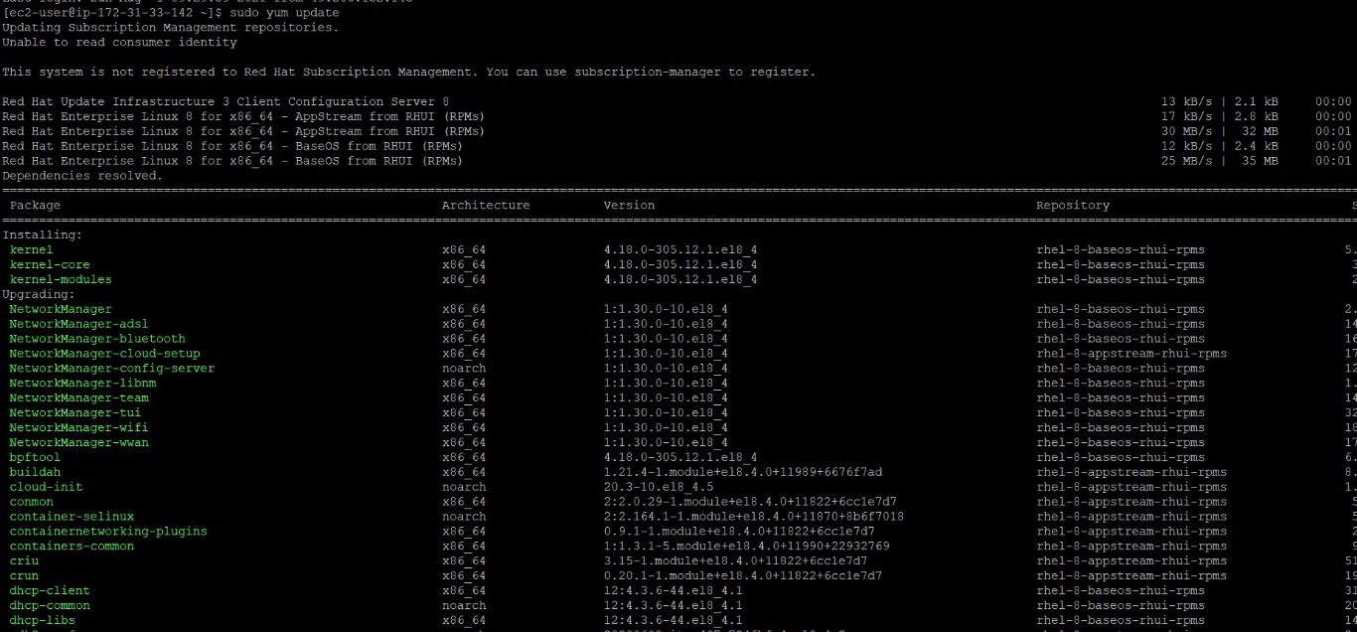

1. sudo yum install docker

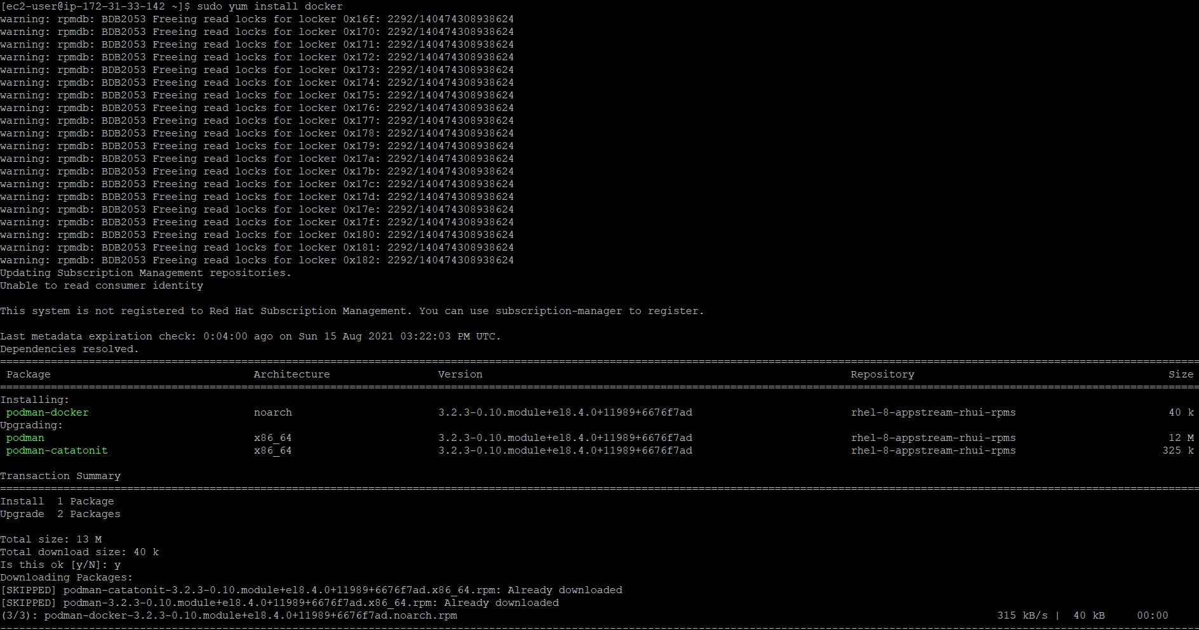

1. docker –version

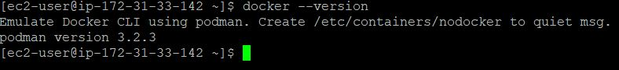

1. service docker start

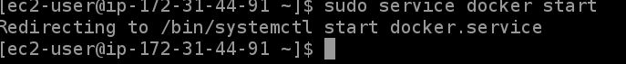

1. service docker status



1. docker run hello-world

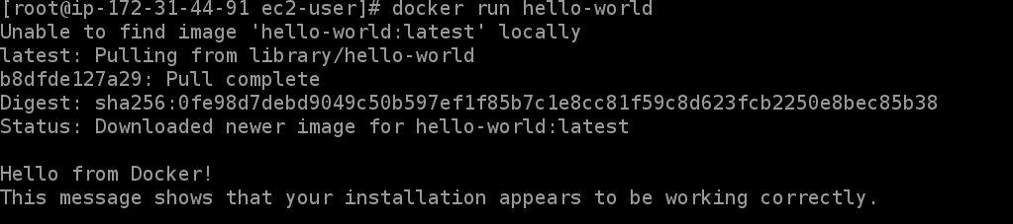

1. docker run -it ubuntu bash

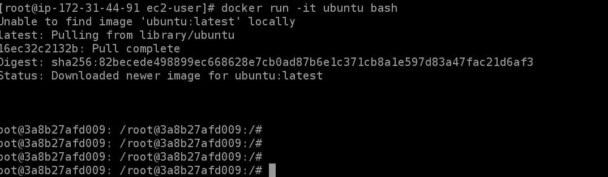

1. docker volume create



1. docker volume ls

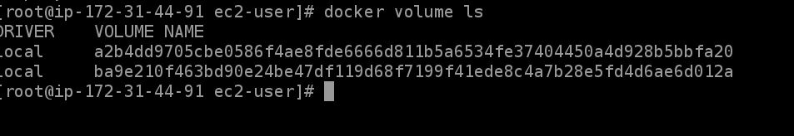

1. 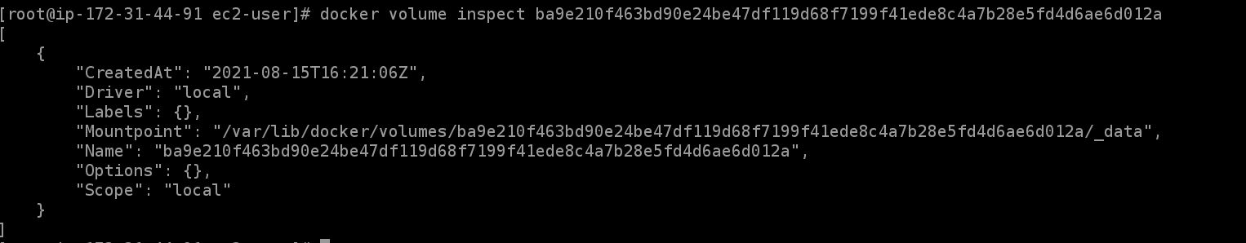docker volume inspect [volume_id]
2. docker volume rm [volume_id]



1. service docker stop
2. docker

